- Purpose

The purpose of this procedure is to describe how to determine the particle size of dry product.

- Scope

This procedure applies to dry product samples.

- Responsibility

Lab Associate is responsible for performing this procedure.

- Safety Considerations

Appropriate PPE is to be worn in the laboratory.

Safety is a condition of employment. Employees are not authorized to work in an unsafe manner and are prohibited from harming the environment of the facility or the community.

- Materials/Equipment

- Dry Product Sample
- Weighing Balance
- Weigh Papers
- Computer – Optiplex 745
- Particle size analyzer – Cilas 1064
- 15 mL Nalgene™ lowboy of DI water, piped into analyzer, with pressurizing bulb
- Flosperse 9000
- 2 - 3ml Droppers
- 25 ml Graduated cylinder
- 50 ml Beaker
- Glass stir rod
- Supply of isopropyl alchohol
- 1 Gallon carboy – catch vessel

- Procedure

- Place a weigh paper on the weighing balance and tare to zero.
- Weigh out 1.00 gram of the dry product sample.
- Pour the sample into a 50 ml beaker.
- Using the 25 ml graduated cylinder measure 20 ml of isopropyl alcohol.
- Pour the alcohol into the 50 ml beaker along with the dry sample.
- Using the glass stir rod, stir the alcohol and the sample to form a slurry.

- Turn on computer, monitor, and Cilas 1064.
- Double click on the Size Expert shortcut.
- Open the Measurement Settings window by clicking on the Measuring Icon in the tool bar.
- Fill the sample chamber of the Cilas 1064 with water by opening the filling water inlet electrovalve in the Mimic Panel window:
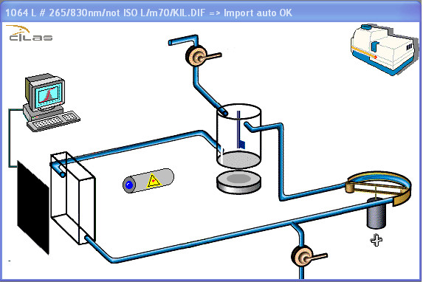
Filling water
inlet electrovalve
Agitator
Peristaltic circulation pump
Ultrasound generator
Drainage electrovalve

If the water does not begin to flow or is flowing too slowly, pump the pressurizing bulb until proper flow is achieved. If the water level in the lowboy is too low, then refill the lowboy and repeat step 5. Once the sample chamber is filled the peristaltic circulation pump will begin circulation.
- Start agitation. To do this, click the agitator in the Mimic Panel window.
- Click on the [Background meas.] button on the left side of the Measurement Settings window. In the window, you will see two progress bars indicating the state of progress of the background measurement. Once the background measurement has been taken, the message “Background measurement OK” should display in the window. If the background measurement is rejected, rinse the sample chamber and try again.
- Start agitation and circulation by clicking the agitator and the peristaltic circulation pump in the Mimic Panel window.
- Add 5 drops of Flosperse 9000 to the sample chamber and wait 45 seconds.
- After 45 seconds click on the [Background meas.] button on the left side of the Measurement Settings window, and take another background measurement. This background measurement will be subtracted from the sample measurement.
- Once the “Background measurement OK” message displays in the window the system is blanked, and the peristaltic circulation pump will automatically turn itself off.
- In the Measurement Settings window enter the sample source and date in “Sample ref.” field.
- Choose the “Sample name”, “Sample type”, “Operator”, Liquid”, and “Dispersal agent” from the dropdown lists.
- Start agitation and circulation.
- Start the ultrasonic generator by clicking on it in the Mimic Panel window.
- Open the Real-time Analysis window by clicking on the Real-time Measuring Icon  in the tool bar.
- Add enough sample slurry to the sample chamber, dropwise to produce an obscuration of around 10% (normally 10 to 15 drops). The obscuration should be monitored in the Real-time Analysis Window as the drops of slurry are added.
- Once the obscuration has stabilized around 10%, click on the [Sample measurement] button on the right side of the Measurement Settings window. The measurement starts and the progress is shown by two indicators. This step will produce the particle size of the sample.
- Once the measurement has been completed, it is automatically saved in the database. The Results window then displays and the chamber is rinsed automatically. If the water does not begin to flow or is flowing too slowly, pump the pressurizing bulb until proper flow is achieved.
- Record the Median reading on the appropriate form, this will be displayed in the Results window as “Diameter at 50%” in μm.
- Click the Print Icon  to print the results. By default, results are printed in a standard report format.
- Label the print out with sample id and date and retain for records.
- Once the Cilas 1064 has drained, turn off the peristaltic circulation pump and agitator.
- Empty the catch vessel located in floor beneath the Cilas 1064.
- Close out program and shut down computer.
- Turn off Cilas 1064.

- Reference Documents

N/A

- Change Information

Updated procedure for use with new Cilas 1064 Particle Size Analyzer.

